UNIX SHELL PROGRAMMING
ASSIGNMENT
GROUP NO : 4[ROLL NOS:44-61]
Submitted By:
-Midhun K.P,44
-Minnu Baby,45
-Rahul Rajan, 53
-Robin Vincent, 56
-SanilSaju, 57
-Sergis Jose, 59
-Thomas Paul, 60
-Yamuna S Soman, 61

SERIES TEST, APRIL 2017
PART I
1.What are the features of BASH shell?
ANS:
Features of BASH shell
--Redirection
Command < file
If we use standard input streams
Command 0< file
Command 1> file, command >> file (to append)
Command >|file (used to forcefully write)
Command 2>&1 (command substitution)
--Command substitution
Convert the output to string. It uses parenthesis.
Eg. (date)
--Reading writing input and output
Eg. read a
echo $a
--Initialise variables
Syntax: variable = value
Eg. a= $1
--Exit status we use $?
--Alias
Customised commands (gives names for commands)
Syntax: alias definition command
Eg. alias x ls
Unalias command

2) Write a script that will add two numbers, which are supplied as command line arguments.
ANS:
#!/bin/csh
# Script Name: fileExtr.CSH
set a=$argv[1]
set b=$argv[2]
@ c = $a + $b
echo $c
- To run : ./fileExtr.csh 5 10

3) With examples show some usage of grep commands.
ANS:
Grep is used to search the input file for all lines that match a specified regular expression and write them to the standard output.
Search for file content specific directory
- To find a list of all files in current directory that contain a pattern
- the l options prints out the filename of any file that has at least one line that matches the grep expression
- grep –l ‘pattern’ *
search all directories in a path
- if you don’t know where the file is located, use the find command with execute criterion
- find ~ -type f –exec grep –l “pattern” {} \;

PART II
4) Bring out the user defined function in awk.
ANS:
Functions are basic building blocks of a program. AWK allows us to define our own functions. A large program can be divided into functions and each function can be written/tested independently. It provides re-usability of code.
Given below is the general format of a user-defined function:

functionfunction_name(argument1,argument2,…)
{
function body
}
In this syntax, the function_name is the name of the user-defined function. Function name should begin with a letter and the rest of the characters can be any combination of numbers, alphabetic characters, or underscore. AWK's reserve words cannot be used as function names.
Functions can accept multiple arguments separated by comma. Arguments are not mandatory. You can also create a user-defined function without any argument.
function body consists of one or more AWK statements.

Example
# Returns minimum number
functionfind_min(num1, num2){
if(num1 < num2)
return num1
return num2
}
# Returns maximum number
functionfind_max(num1, num2){
if(num1 > num2)
return num1
return num2
}
# Main function
function main(num1, num2){
# Find minimum number
result=find_min(10,20)
print"Minimum =", result

# Find maximum number
result=find_max(10,20)
print"Maximum =", result
}
# Script execution starts here
BEGIN{
main(10,20)
}

Output
Minimum = 10
Maximum = 20

5) Explain eval command with an example.
ANS:
eval Command
- The eval command is used when the Korn shell needs to evaluate a command twice before executing it.
- To generalize a segment of code, we need to store the name of a variable in a second variable and then use the print command to display the value of the original variable.
- $ x=23
- $ y=x
- $ print $y
- X
- The solution is to use the eval command so that the shell evaluates the command twice.
- $ x=23
- $ y=x
- $ eval print \$$y
- 23
- When the eval command is executed, it first evaluates $y, which generates the string value $x.
- The second evaluation then evaluates the variable $x, which produces the correct effect, the printing of the variable stored in y.

6) With examples explain different string functions in awk.
ANS:
---index
Returns the first position of a substring within a string.
Syntax:
index(string,substring)
Example:
{
loc=index(MISSISSIPI, ”IS” )
print loc
}
output: 2
---length
Length returns the number of characters in the string.
Syntax:
length(string)
Example:
{
len=length($0)
print len
}
---substring
Extracts a substring from a string
Syntax:
substr (string , position)
substr (string , position, length)
Example:
{
sub =substr (missisipi , 3)
sub =substr (missisipi , 3, 3)
}
---split
split(string, array)
split(string, array, fieldseparator)
  - divides string into pieces separated by fieldseparator, and stores the pieces in array
  - if the fieldseparator is omitted, the value of FS is used.
Example:
split("auto-da-fe", a, "-")
sets the contents of the array a as follows:
a[1] = "auto"
a[2] = "da"
a[3] = "fe"
---substitution
Substitute one string value for another
Syntax:
sub (reg _exp, replacementstring , inputstring)
Example:
success=sub (/bird/, ”animal”, $0)
sub returns 1 , if substitution was successful otherwise 0
---global substitution
Substitute all occurrences of a value
Syntax:
gsub (reg _exp, replacementstring , inputstring)
Example:
gsub (/bird/, ”animal”, $0)
---match
Returns the starting position of the matching expression
Syntax:
startpos=match (string, regexp)
Example:
startpos=match ($0, regexp)
---tolower(string)
returns a copy of string, with each upper-case character converted to lower-case. Nonalphabetic characters are left unchanged.
Example:tolower("MiXeDcAsE 123")
returns "mixed case 123"
---toupper(string)
returns a copy of string, with each lower-case character converted to upper-case.

PART III

7) With suitable examples, explain sed commands.
ANS:
sed:
- sed scans the input file, line by line, and applies a list of instructions(sed script) to each line in the input file.
- the script ,which is usually a separate file, can be included in the sed command line if it is a one line command
- it does not change anything in the original file
sed script:
- sed requires one or more instructions that provides the editing criteria
- when there is only one command, it may be entered from the keyboard
- mostly instruction are placed in a file(sed script)
- each instruction in a sed script contains an address and a command
sed script format:
- instructions included in command line
sed -e ‘address command’ input _file
- instructions placed in a file
sed –f script.sed input _file
create script file using text editor
save file with .sed extension
sed commands:
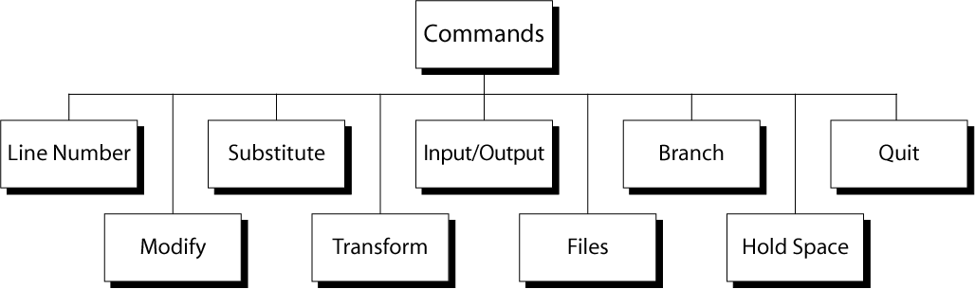

i)line number
- put line number at the beginning of the line
- line number is written on a separate line
Eg
sed “=” file1
sed “/^o/=“ file1
ii)modify
Eg
insert.sed
1i\
hello
sed -f insert.sedinput_file

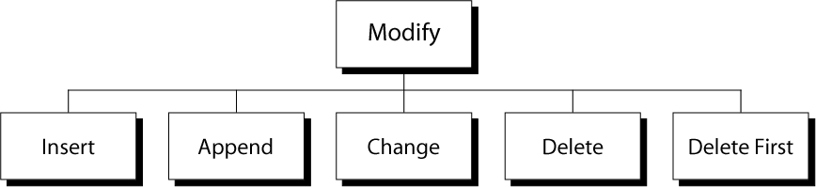
iii)substitute
input file
mary had a white cat and a black cat
sed ‘1 s/cat/dog/’ input file
output
mary had a white dog and a black cat
iv)transform
sed ‘y/aeiou/AEIOU’ input_file
v)I/O
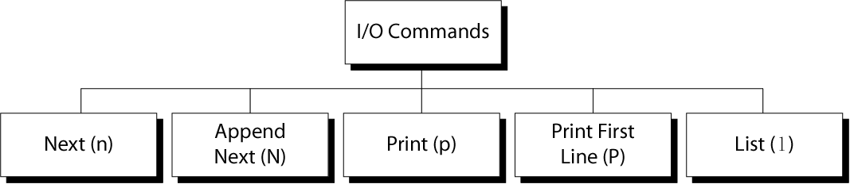
Eg:/^[0-9]/{
n
/^a/d
}
vi)file
- script.sed
1 r hai.dat
- hai.dat
what is your name

- inputfile
hello how are you
where are you from
vii)branch
  - branch command(b)
  - branch on substitution(t)
viii)hold space
h and H
g and G
ix)quit
Syntax:[addr]q
  - Quit (exit sed) when addr is encountered.

OR
8) Explain the use of awk command and its associative arrays with suitable examples.
ANS:
awk command searches files for text containing a pattern. When a line or text matches, awk performs a specific action on that line/text. The Program statement tells awk what operation to do; Program statement consists of a series of "rules" where each rule specifies one pattern to search for, and one action to perform when a particular pattern is found. A regular expression enclosed in slashes (/) is an awk pattern to match every input record whose text belongs to that set.
Examples
To print the length of the longest input line.
$ awk '{ if (length($0) > max) max = length($0) } END { print max }' sample.txt
13
To print seven random numbers from zero to 100, inclusive.
$ awk 'BEGIN { for (i = 1; i<= 7; i++) print int(101 * rand()) }'
24
29
85
15
59
19
81

Associative arrays
- Arrays with the index values as string are called associative arrays.
- Index must be unique: each index must be associated with an array value only once.
- Data values may be duplicated.
- The association of the index with its value is guaranteed.
- There is no ordering imposed on the indexes.
- An array index cannot be sorted. The data values in the array can be sorted.

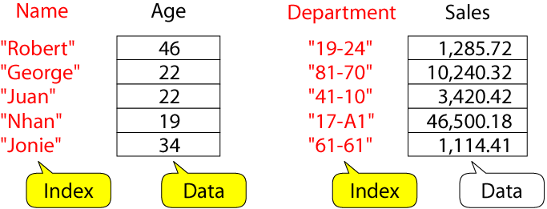

Example: process sales data
- input file:
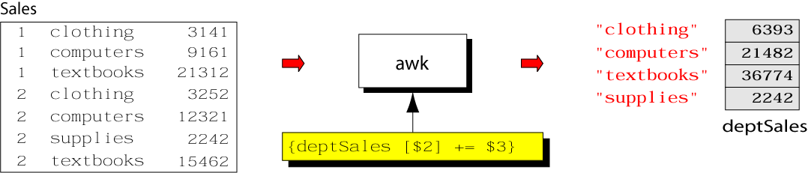

- output:
  - summary of category sales
- awk program:
% cat sales.awk
{
deptSales[$2] += $3
}
END {
for (x in deptSales)
print x, deptSales[x]
}
% awk –f sales.awk sales

9) Write a shell script to print a number in reverse order.
ANS:
#!/bin/bash
echo “Enter the number”
read no
rev=0
while [ $no –gt 0 ]
do
no=`expr $no % 10`
rev=`expr $rev * 10`
rev=`expr $rev + $rem`
no=`expr $no / 10`
done
echo “Reverse is”
echo $rev

Save as rev.sh
$sh rev.sh

OR
10) Write a shell script to find the sum of digits of a number.
ANS:
#!/bin/bash
echo “Enter the number”
read no
s=0
while [ $no –gt 0 ]
do
rem=`expr $no % 10`
s=`expr $s + $rem`
no=`expr $no/ 10`
done
echo “The sum of digits is”
echo $sum

Save as sum.sh
$sh sum.sh

11) Explain command history and command execution process.
ANS:
Command Execution Process:
- To understand the behaviour of the shell, it helps to understand how C executes a command. Command execution is carried out in six sequential steps
- Command parsing
- Variable evaluation
- Command substitution
- Redirection
- Wildcard expansion
- Path determination
Command Parsing
The shell first parses the command into words. In this step, it uses whitespaces as delimiters between the words. It also replaces sequences of two or more spaces or tabs with a single space.
Variable Evaluation
After completely parsing the command, the shell looks for variable names (unquoted words beginning with a dollar sign). When a variable name is found, its value replaces the variable name
Command Substitution
The shell then looks for a command substitution. If found, the command is executed and its output string replaces the command
Redirection
At this point, the shell checks the command for redirected files. Each redirected file is verified by opening it.

Wildcard Expansion
When filenames contain wildcards, the shell expands and replaces them with their matching filenames. This step creates a file list.

Path Determination
In this last step, the shell uses the PATH variable to locate the directory containing the command code. The command is now ready for execution.
History Command:
- The command for listing, editing and executing commands from the history file
- Executed without any options , the history commands lists the last 16 commands.
- history
- We can control the number of commands listed by providing a number as a history command argument
- history 10
Reexecuting previous commands
- Commands in the history file can be re-executed
- The command to re-execute the previous command is the ! Character
- The specific command to be reexecuted can be specified in four ways
- Two consecutive bangs (!!)
- A positive number, specifies the command number(!n)
- A negative number which specifies the command relative to the current command(!-n)
- A string which is used to match a part of the command to be reexecuted(!string)
Substitute and re-execute
- We can make changes to a command before we reexecute it
- The changes are specified as a substitute pattern (s/../../)
- The substitute pattern immediately follows the reexecutecommads and is seperated from it by a semicolon
- lsErrfile
- !ls:s/Errfile/file1/
Using arguments from previous command
- It is possible to use any or all arguments from the previous command
- To specify the last argument is to be used , we code the new command followed by history previous command(!) and a dollar sign($)
- To specify all arguments to be used , we code the new command followed by history previous command (!) and an asterik (*)
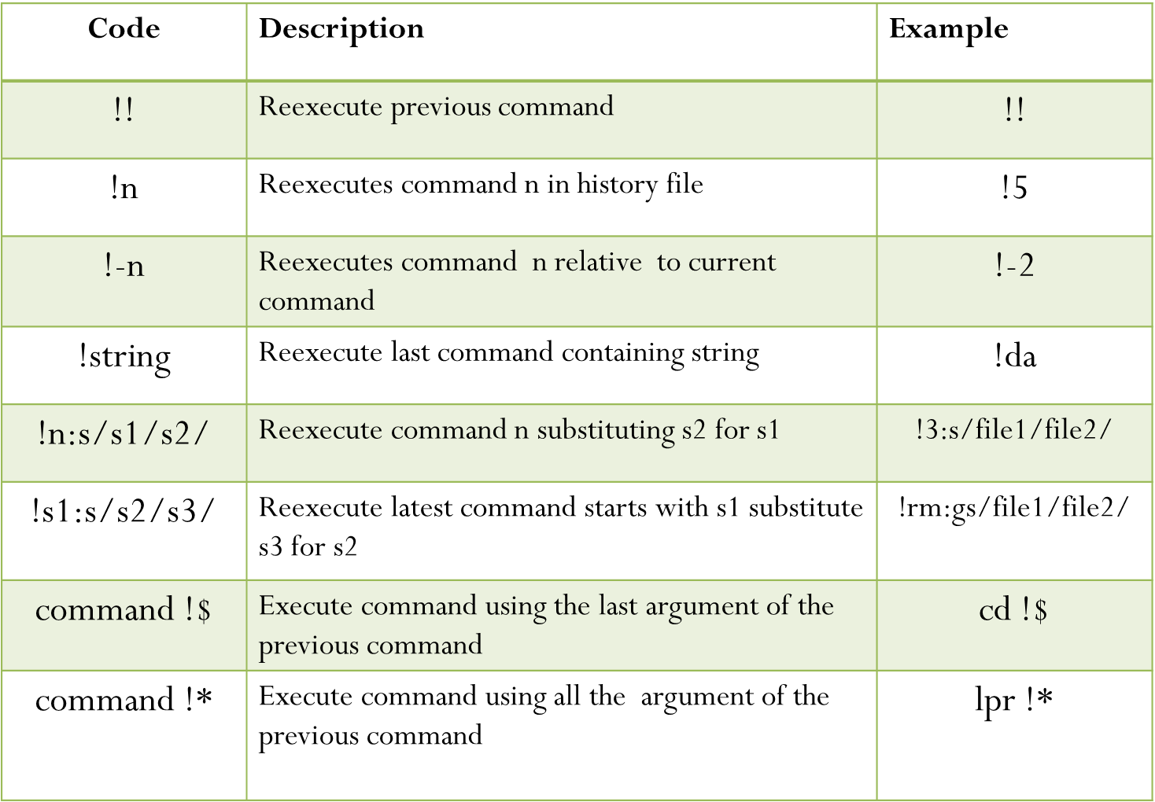

OR
12) Write a script using case statement to perform basic math operations as follows
+ addition
- subtraction
* multiplication
/ division
The name of script must be ‘calc’ which works as follows
$ sh calc.sh 20 + 3
Also check for sufficient command line arguments.

ANS:
calc.sh
If [ $# != 3]
then
echo “ insufficient command line arguments “
else
a= $1
b= $2
c= $3
case $2 in
+) r=`expr $a+ $c`
echo “ $a+ $c= $r”
;;
-) r= `expr $a - $c`
echo “ $a- $c = $r”
;;
\*) r= `expr $a\* $c`
echo “ $a * $c = $r”
;;
/) r= `expr $a / $c `
echo “$a/ $c = $r”
;;
esac
fi

